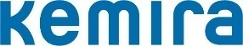
WE A R E L O O K ING F O R
Intern in IT Department
L O C AT I ON G D A N S K (POLAND)

Kemira is a global company providing chemicals and expertise to operations around the world. We are committed to being our customers’ first choice by bringing sustainable value through improved product quality, better process and resource efficiency. We offer a result-oriented and collaborative culture that empowers you to drive excellence and innovation with a major impact on the future. If you have the right mix of curiosity, a drive for excellence and an innovative mindset, we want to talk to you.

We are now looking for an Intern with Finnish & English for our IT Department in Kemira Gdańsk.
Service Desk Agent with Finnish Language for internship in EMEA Service Desk Team is a great opportunity to take on IT career path. You will work in a multinational team of IT specialists who are a first line of technical support for our company. It is a chance to expand your skills by adding customer experience, technical knowledge and professional approach to what you already bring.

Kemira’s Business Service Center in Gdańsk, Poland is a multifunction service center with customer service, procurement, finance and administration and IT operations. It is a dynamic and multicultural center that values openness, cooperation and partnership.

What you will learn with us:
- being a first point of contact for company employees who experience technical issues;
- categorizing and recording reported incidents resolution process;
- investigating and resolving or escalating incidents to 2nd and 3rd party support Teams;
- fulfilling technical requests related to hardware or software maintenance;
- advising users in matters related to IT security and company procedures.

What you need:

- advanced written and spoken Finnish language skills;
- basic knowledge of Microsoft products (Windows10, Office 365, Teams, OneDrive);
- good communication skills;
- basic knowledge about networks/servers and curiosity about IT in general would be an asset;

BENEFITS & MORE
...and much, much more
DEVELOPMENT POSSIBILITIES
INTERNATIONAL WORK ENVIRONMENT
SOCIAL & INTEGRATING ACTIVITIES
GREAT OFFICE
SALARY

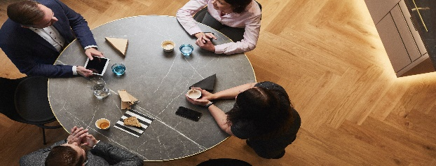
Please apply with CV by the link: https://bit.ly/2PlZ4cM
Deadline for applications: 7.04.2020
Preferred start date: May 2020 (exact date to be agreed during interview)
Min. duration: around 6 months
Find the right mix of experiences and opportunities at Kemira

Dear Candidate, please include in your CV the following statement:
I hereby voluntarily consent to the processing of my personal data included in the application documents delivered by me to Kemira Gdańsk Spółka z o.o. with its registered office in Gdańsk, ul. Grunwaldzka 411.

