 **WE A R E L O O K ING F O R**

**Intern in Customer Service Department**

**L O C AT I ON G D A N S K (POLAND)**

Kemira is a global company providing chemicals and expertise to operations around the world. We are committed to being our customers’ first choice by bringing sustainable value through improved product quality, better process and resource efficiency. We offer a result-oriented and collaborative culture that empowers you to drive excellence and innovation with a major impact on the future. If you have the right mix of curiosity, a drive for excellence and an innovative mindset, we want to talk to you.

We are now looking for an **Intern with Finnish & English** for our Customer Service Department in Kemira Gdańsk.

**Kemira’s Business Service Center in Gdańsk**, Poland is a multifunction service center with customer service, procurement, finance and administration and IT operations. It is a dynamic and multicultural center that values openness, cooperation and partnership.

**What you will learn with us:**

* receiving, processing and verifying the customers’ orders,
* ensuring customer requirements are properly documented and communicated,
* organizing product transport,
* handling all of the orders in SAP system,
* taking care of deliveries, freight cost planning and documentation to be correct and available in time for transport,
* cooperation with different departments within Kemira.

**What you need:**

* native/fluent level of Finnish,
* very good level of English,
* education: final year student of vocational/secondary school,
* MS Office knowledge,
* good communication skills (both written and spoken),
* other language skills would be an asset (Swedish, German, Dutch, Spanish, Italian, French).

**BENEFITS & MORE**





**...and much, much more**

DEVELOPMENT POSSIBILITIES

INTERNATIONAL WORK ENVIRONMENT

SOCIAL & INTEGRATING ACTIVITIES

GREAT OFFICE

SALARY

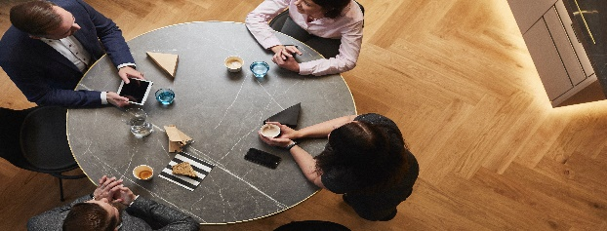

**Please send your CV to: ext.alicja.golata@kemira.com**

**Deadline for applications:** 13.04.2021

**Preferred start date**: May 2021 (exact date to be agreed during interview)

**Min. duration:** around 6 months

**Find the right mix of experiences and opportunities at Kemira**

Dear Candidate, please include in your CV the following statement:

*I hereby voluntarily consent to the processing of my personal data included in the application documents delivered by me to Kemira Gdańsk Spółka z o.o. with its registered office in Gdańsk, ul. Grunwaldzka 411.*